DESIGN AND IMPLEMENTATION OF A WEB-BASED SCHOOL MANAGEMENT SYSTEM WITH AUTOMATED RESULT GRADING AND PARENT COMMUNICATION

BY
IGOCHE, FRANCIS
CS/2022/1349

SUBMITTED TO
THE DEPARTMENT OF COMPUTER SCIENCE FACULTY OF NATURAL SCIENCES CARITAS UNIVERSITY,
AMORJI-NIKE, ENUGU

IN PARTIAL FULFILMENT OF THE REQUIREMENTS FOR THE AWARD OF BACHELOR OF SCIENCE (B.SC) DEGREE IN
COMPUTER SCIENCE

AUGUST, 2026

DECLARATION
I, IGOCHE, FRANCIS, with registration number CS/2022/1349, hereby declare that this project titled "Design and Implementation of a Web-Based School Management System with Automated Result Grading and Parent Communication" is my original research work carried out under the supervision of Mr. Ugwu Ejike of the Department of Computer Science, Caritas University, Amorji-Nike, Enugu. The work reported herein has not been presented, in whole or in part, to any institution for the award of any other degree or qualification, and all sources consulted have been duly acknowledged.
________________________________ ________________________

Igoche, Francis Date
(CS/2022/1349)

APPROVAL
This is to certify that we have read, examined and found this project titled "Design and Implementation of a Web-Based School Management System with Automated Result Grading and Parent Communication", carried out by IGOCHE, FRANCIS with registration number CS/2022/1349, to be satisfactory and acceptable for the award of a Bachelor of Science (B.Sc) degree in Computer Science of Caritas University, Amorji-Nike, Enugu, and hence we have caused our names and signatures to appear as follows:
________________________________ ________________________

Mr. Ugwu Ejike Date
(Project Supervisor)
________________________________ ________________________

Mr. Ugwu, Ejike Date
(Head of Department)
________________________________ ________________________

Prof. Fergus Onu Date
(External Examiner)

DEDICATION
This project is dedicated to Almighty God, the giver of wisdom and understanding, for His grace and guidance throughout the course of this programme, and to my family, whose patience, encouragement and unfailing support made this academic journey possible.

ACKNOWLEDGEMENTS
I extend my sincere gratitude to God Almighty for the strength, wisdom and good health that sustained me throughout the duration of this project.
My profound appreciation goes to my Project Supervisor, Mr. Ugwu Ejike, whose guidance, patience and constructive criticism shaped this work from conception to completion.
I am equally grateful to the Head of the Department of Computer Science, Mr. Ugwu, Ejike, for his leadership and support throughout the programme. My sincere thanks go likewise to Prof. Arinze Nwaeze, Dr. Henry Nweke and Dr. Ugochukwu Nwankwo, and to all the other lecturers of the Department of Computer Science, Caritas University, for the knowledge imparted to me over the course of my studies.
Finally, I thank my family and friends for their encouragement, understanding and support throughout the period of this project.

ABSTRACT
This work reports on SchoolPro, a web-based school management system developed to bring a secondary school’s core administrative processes — student registration, daily attendance, result computation, fee collection and parent communication — into a single, role-gated dashboard. It analysed the fragmented, largely manual manner in which these records are presently kept, often across separate paper registers and ledgers, and used the findings to design a system in which a signed-in administrator maintains a central student register, marks daily class attendance, records continuous-assessment and examination scores that are converted automatically into WAEC-scale grades, tracks fee collection per student and term, and issues SMS and push broadcasts to parents. The system was designed using the Object-Oriented Analysis and Design Methodology and implemented as a React single-page application, compiled to a single self-contained file and deployed on Netlify.

TABLE OF CONTENTS
Title Page i
Declaration ii
Approval iii
Dedication iv
Acknowledgements v
Abstract vi
Table of Contents vii
List of Tables ix
List of Figures x
CHAPTER ONE: INTRODUCTION 1
1.1 Background of the Study 1
1.2 Statement of the Problem 2
1.3 Aim and Objectives of the Study 2
1.4 Significance of the Study 2
1.5 Scope of the Study 3
1.6 Limitations of the Study 3
1.7 Definition of Terms 4
1.8 Organization of the Report 5
CHAPTER TWO: LITERATURE REVIEW 6
2.1 Introduction 6
2.2 School Management Information Systems 6
2.3 Technology Adoption 6
2.4 Automated Grading and Assessment Computation 7
2.5 Parent–School Communication Systems 8
2.6 The Single-Page Application Model 8
2.7 Usable Interface Design 8
2.8 Review of Related and Existing Systems 9
2.9 Data Privacy and Security Considerations in School Information Systems 10
2.10 Responsive and Mobile-First Interface Design in Resource-Constrained Settings 11
2.11 Summary and Research Gap 12
CHAPTER THREE: SYSTEM ANALYSIS AND METHODOLOGY 13
3.1 Data Gathering 13
3.2 Research Methodology and Justification 13
3.3 System Analysis 13
3.3.1 Analysis of the Existing System 13
3.3.2 Analysis of the Proposed System 14
3.3.3 Feasibility Study 14
3.4 Justification of the Proposed System 15
3.5 Requirements Specification 16
3.5.1 Functional Requirements 16
3.5.2 Non-Functional Requirements 16
3.6 System Modelling: Data Flow Diagram 17
3.7 Project Implementation Schedule 18
CHAPTER FOUR: SYSTEM DESIGN AND IMPLEMENTATION 19
4.1 Design and Specification of the Proposed System 19
4.1.1 Input Design and Specification 19
4.1.2 Output Design and Specification 19
4.1.3 Security Design and Specification 20
4.1.4 Data Design and Specification 20
4.1.5 Database and File Design 21
4.2 System Development Tools and Justification 22
4.3 System Requirements 25
4.3.1 Hardware Requirements 25
4.3.2 Software Requirements 25
4.4 Implementation of the Proposed System 26
4.4.1 Module Implementation Narrative 26
4.5 System Testing and Validation 27
4.5.1 Unit Testing 27
4.5.2 Integration Testing 27
4.5.3 System Testing 27
4.5.4 User Acceptance and Usability Testing 28
CHAPTER FIVE: SUMMARY, CONCLUSION AND RECOMMENDATIONS 30
5.1 Summary 30
5.2 Conclusion 30
5.3 Recommendations 31
5.4 Contribution to Knowledge 31
REFERENCES 33
APPENDIX A: SOURCE CODE SNIPPETS 35
APPENDIX B: SAMPLE OUTPUTS (SCREENSHOTS) 38
APPENDIX C: USER OPERATION MANUAL 42
LIST OF TABLES
Table 2.1: Comparison of School Management System Categories 9
Table 3.1: Functional Requirements 16
Table 3.2: Non-Functional Requirements 16
Table 3.3: Project Implementation Schedule 18
Table 4.2: The Student Record 20
Table 4.1a: Principal Record Types and Relationships 21
Table 4.3: Representative System Test Cases and Outcomes 27
Table 4.4: Usability Evaluation — Mean Ratings 28
LIST OF FIGURES
Figure 3.1: Context-Level (Level 0) Data Flow Diagram of SchoolPro 17
Figure 4.2: Use Case Diagram of SchoolPro 23
Figure 4.3: Sequence Diagram — Sign-In and Attendance Recording 24
Figure 4.4: Class Diagram of the Core Domain Model 25
Figure B.1: The administrator sign-in gate 38
Figure B.2: The dashboard — total students, pending fees, class average and SMS-delivery meter at a glance 39
Figure B.3: The Student Register 39
Figure B.4: The Daily Attendance module 39
Figure B.5: The Auto-Result Grading view, showing WAEC-scale grades computed from CA and examination scores 40
Figure B.6: The Fee Management view 40
Figure B.7: The Parent Communications module, showing the broadcast delivery report 41

CHAPTER ONE
INTRODUCTION
1.1 Background of the Study
A secondary school’s day-to-day administration depends on several distinct but related records being kept accurately and consistently: who is enrolled and in which class, who was present on a given day, what each student scored in each subject and what grade that score represents, whether a student’s fees are paid up for the term, and how the school communicates routine information to parents. In many Nigerian secondary schools, these records are still kept separately — a paper attendance register, a ledger for fee payments, examination scripts marked and transcribed by hand into a result sheet, and parent contact carried out informally by phone or through printed notes sent home with the student.
Keeping these records apart creates avoidable friction. A class teacher totalling continuous-assessment and examination scores by hand must also look up the WAEC grading scale to convert each total into a letter grade, a repetitive task prone to arithmetic error. A bursar tracking fee payments in a separate ledger has no direct link to the student register, so identifying which students in a class still owe requires manual cross-referencing. A school wishing to reach a specific group of parents — the parents of one class, for instance — has no single list to message against. It was this fragmentation, and the repetitive manual computation it involves, that prompted the development of the system reported in this project.
The consequence of this fragmentation is felt most acutely at the points where two records must be read together. A school seeking to identify students who are both behind on fees and frequently absent, for example, must place a fee ledger and an attendance register side by side and cross-check them by hand, a task that grows steadily slower as the class list grows longer. Likewise, a class teacher preparing a term result sheet must total each student's continuous-assessment and examination scores, then consult a printed WAEC grading table to find the corresponding letter grade, repeating the same lookup for every subject and every student in the class. Neither task is conceptually difficult, but both are repetitive, time-consuming, and exactly the kind of routine, rule-based work that a computer-based system is well suited to remove.
SchoolPro is proposed as a response to this fragmentation: a single, role-gated, web-based dashboard in which an administrator maintains the student register, records daily attendance, enters assessment scores that are converted automatically into WAEC-scale grades, tracks fee collection per student and term, and issues SMS or push broadcasts to parent groups — five previously separate processes consolidated into one system.
1.2 Statement of the Problem
Secondary school administration in the present, largely manual arrangement lacks a single system in which student records, attendance, results, fees and parent communication are held and acted upon together. Because these processes are kept separately, a school cannot readily answer a simple question — which students in a given class are both behind on fees and absent above a certain rate, for instance — without manually cross-referencing multiple registers and ledgers. Result computation in particular is repetitive and error-prone when scores are converted to grades by hand against a fixed scale. This absence of a unified, administrator-facing system gives rise to slower record-keeping, a higher risk of computational error in grading, and no efficient means of reaching parents as a group.
1.3 Aim and Objectives of the Study
The aim of this project is to design and implement a web-based school management system that consolidates student registration, attendance, automated result grading, fee management and parent communication into a single administrator dashboard. The specific objectives, each aimed at mitigating the problem stated in Section 1.2, are:
1. To design a central student register holding each student’s identifying and contact details, so that a single record of enrolment replaces separate class lists.
2. To implement a daily attendance module in which a class’s attendance is marked and retained as a per-date, per-student record.
3. To implement an automated result-grading engine that converts a continuous-assessment and examination score into a WAEC-scale grade (A1–F9) without manual lookup, together with the associated remark.
4. To implement a fee-management view that records amounts due and paid per student and term, and surfaces which students are currently owing.
5. To implement a parent-communication module through which a broadcast message can be composed and issued, by SMS or push notification, to a named parent group.
1.4 Significance of the Study
When completed, this work contributes a practical, consolidated administrative tool for a secondary school. By bringing five previously separate processes into one dashboard, it removes much of the manual cross-referencing and repetitive computation the existing arrangement requires. The following points further underline the importance of the study:
• Accuracy is improved, because the conversion of a score to a WAEC grade is computed by a fixed function rather than looked up by hand.
• Efficiency is increased, because a single dashboard replaces separate registers, ledgers and contact lists for related information.
• Reach is improved, because a broadcast can be issued to an entire parent group at once rather than contacted individually.
• The work also serves as a reference for students and developers interested in role-gated administrative dashboards, automated grade computation, and single-page application design delivered without heavy server infrastructure.
1.5 Scope of the Study
This project covers the design, implementation and evaluation of a web-based school management system that runs in a standard web browser. Its scope covers administrator sign-in; a student register with add and edit operations; a daily, per-class attendance record; a result-entry and automated WAEC-scale grading view; a fee-management view recording amounts due and paid per student and term; and a parent-communication view for composing and issuing broadcasts by SMS or push notification to a named group. The system is intended for use by the administrative staff of a secondary school.
The study is bounded as follows. It concerns the recording and presentation of the five processes named above within a single administrator-facing application, and does not undertake the actual transmission of an SMS or push message to a real telecommunications gateway, nor the processing of an actual fee payment. Its content is held in structured collections within the browser to demonstrate every view at realistic scale; connection to a central server, a database and a live messaging or payment gateway is identified in Section 5.3 as further work rather than undertaken here.
1.6 Limitations of the Study
Several factors constrained the execution of this work and should be borne in mind when interpreting its results.
First, the system is a functional prototype whose content is held in in-browser collections rather than in a server-side store. The seeded student register, attendance, results, fees and broadcast log are realistic and stable across a session, but a change made during a session — a student added, attendance marked, a broadcast composed — is not written to a persistent store and does not survive a page reload, because no server or database is provisioned in this build. The introduction of a persistence layer is identified in Section 5.3 as the first priority for further work.
Second, administrator sign-in in the present build is performed within the browser against a single demonstration credential, and is intended to exercise the access-gated design rather than to secure a real staff account. Per-staff credentials verified on a server against irreversibly hashed values are likewise identified as further work.
Third, the parent-communication module composes and logs a broadcast within the application but does not connect to a real SMS gateway or push-notification service, and the fee-management view records payment status rather than processing an actual transaction.
Fourth, the study was carried out within a single academic session alongside coursework and examinations, which constrained the duration of the evaluation exercise.
1.7 Definition of Terms
School Management System — a computer-based application that gathers, stores and coordinates the administrative records — such as enrolment, attendance, results, fees and communication — that a school depends upon.
Administrator Dashboard — the central, role-gated interface through which a signed-in staff member reaches each of the system's modules from a single point of entry.
WAEC Grading Scale — the fixed mapping, published by the West African Examinations Council, from a numeric score to a letter grade (A1 through F9) and an associated remark, used throughout Nigerian secondary education.
Continuous Assessment (CA) — the component of a student's term score derived from classwork, tests and assignments completed before the examination, combined with the examination score to produce the total on which a grade is computed.
Single-Page Application (SPA) — a web application that loads one document into the browser and switches between its several views on the client, without requesting a full new page from a server for each view.
1.8 Organization of the Report
The remainder of this report is organised as follows. Chapter Two reviews the literature bearing on school management information systems, technology adoption, automated grading, parent–school communication, data privacy and responsive interface design, and identifies the research gap this study addresses. Chapter Three sets out the methodology adopted, analyses the existing manual arrangement and the proposed system, specifies the functional and non-functional requirements, models the system's data flow, and presents the project implementation schedule. Chapter Four documents the design and implementation of the system, including its architecture, its use case, sequence and class diagrams, its development tools, and the testing and evaluation carried out. Chapter Five summarises the work, states its conclusions and recommendations, and closes with its contribution to knowledge. The report ends with the list of references and three appendices: representative source code, sample outputs, and an operation manual for the system.
Role-Gated Access — an arrangement in which the views and data of a system are reached only after a user's credential has been verified, restricting an unauthenticated visitor to the sign-in form alone.
Broadcast — a single message composed once by the administrator and issued, by SMS or push notification, to every parent within a named target group rather than to one parent at a time.
Client-Side Data — data held within structures resident in the browser during a session, as distinct from data written to and retrieved from a server-hosted database.
CHAPTER TWO
LITERATURE REVIEW
2.1 Introduction
This chapter reviews the body of literature relevant to the design of a web-based school management system. It begins by framing such a system within the broader theory of information systems and technology adoption, then turns to the specific technical concerns the present system addresses: automated grading, parent–school communication, the single-page application model and usable interface design. Each body of work is related to the present project, with its contribution and its limitation identified, and the chapter concludes by stating the gap that the study addresses.
2.2 School Management Information Systems
The general practice of using a computer-based system to collect, store and coordinate the records an institution depends upon is treated in the information-systems literature. Laudon and Laudon (2020) describe an information system as a set of interrelated components that gather, process, store and distribute information to support coordination within an organisation. This framing positions the present project as an information system in the fullest sense: SchoolPro exists to coordinate five related administrative processes — registration, attendance, results, fees and parent communication — that a school otherwise keeps apart. The limitation of so general a framework, for a system builder, is that it establishes the purpose of such a system without prescribing its concrete structure; the present study supplies that structure for the specific case of a Nigerian secondary school.
A related strand of this literature distinguishes a transaction-processing view of such a system, concerned only with recording individual events such as a single attendance mark or a single fee payment, from a management-information view, concerned with what those recorded events reveal in aggregate — a class's attendance rate over a term, for instance, or the proportion of a class currently owing fees. SchoolPro is deliberately built to satisfy both views at once: each module records an individual event as it occurs, while the dashboard's summary cards aggregate those same events into the kind of overview an administrator needs before deciding where to look next.
2.3 Technology Adoption
Whether an administrative staff member actually uses a new system, rather than continuing to rely on the paper process it is meant to replace, depends on its acceptance. The Technology Acceptance Model, formulated by Davis (1989), holds that adoption is governed chiefly by perceived usefulness and perceived ease of use. This bears directly on the present work: a school administrator will adopt SchoolPro only if it is clearly faster than the manual register or ledger it replaces, and only if operating it requires no special training. These considerations informed the consolidation of five processes into a single dashboard reachable from one sign-in, and the immediate, no-lookup conversion of a score into a grade discussed in Section 2.4.
A further refinement of this model, proposed by Venkatesh and Davis (2000) as the Technology Acceptance Model 2, adds subjective norm — the influence of what colleagues and superiors are seen to use — as a further predictor of adoption alongside perceived usefulness and ease of use. Applied to the present context, this suggests that a school's administrative staff are more likely to adopt SchoolPro consistently if its use is visibly endorsed and modelled by the head of department or principal, rather than left to individual staff discretion, a consideration that falls outside the system's design but bears on its eventual rollout.
2.4 Automated Grading and Assessment Computation
A central concern of the present system is the conversion of a continuous-assessment and examination score into a standard letter grade without manual lookup. The West African Examinations Council’s grading scale (WAEC, 2023) defines a fixed mapping from a numeric score to a letter grade — A1 through F9 — and an associated remark such as “Excellent” or “Credit”. This scale is well established in Nigerian secondary education and is the scale the present system’s grading engine implements directly, converting a total score to its grade and remark deterministically rather than by manual reference to a printed table. Ifenthaler and Widanapathirana (2014), writing on the wider use of computed indicators to represent student performance, note that an automatically derived grade is only as trustworthy as the fixed rule that produces it, and that the rule should therefore be simple, transparent and directly inspectable — a principle the present system satisfies by implementing the WAEC scale as a single, readable function rather than a more elaborate or opaque scoring model.
The cost of manual grade conversion is not merely clerical. Black and Wiliam (1998), in an influential review of classroom assessment practice, argue that the value of an assessment lies substantially in how promptly and accurately its result is fed back to the student, since feedback that arrives late or is mistrusted for its accuracy does little to guide subsequent learning. A WAEC-scale conversion performed by hand across a full class list is exactly the kind of repetitive task in which an isolated arithmetic slip is both likely and, once a result sheet is compiled, difficult to trace back to its source. By computing the grade directly from the entered score through the fixed function described in Section 4.1.4, SchoolPro removes this specific point of failure, returning a grade the moment a score is entered rather than after a separate manual conversion step.
2.5 Parent–School Communication Systems
The practice of using bulk SMS and push notification to keep parents informed is well established in the school-management software literature. Olumide and Adebayo (2019), reviewing school management systems deployed in Nigerian secondary schools, report that SMS-based parent notification is among the most consistently valued features of such systems, because it reaches a parent directly without depending on the student to relay a printed note. The present system’s Parent Communications module applies this finding directly, allowing a broadcast to be composed once and addressed to a named parent group — the parents of a specific class, for instance — by SMS or push channel. The honest limitation, relative to a production deployment, is that the present build composes and logs the broadcast within the application rather than dispatching it through a real telecommunications gateway, a distinction discussed further in Section 4.1.3.
2.6 The Single-Page Application Model
The architectural model of the present system is that of the single-page application, in which one document is loaded once and its several views are switched and re-rendered on the client without further full-page loads. Mikowski and Powell (2013) set out this model, in which the browser holds the application’s state and updates the interface in response to user action. The present dashboard is a direct instance: its student register, attendance, results, fees and communications views are switched entirely on the client, built here using React — a component-based library for constructing exactly this kind of interface, described by Banks and Porcello (2020) as organising an application into small, composable pieces of interface state, each re-rendering independently as its underlying data changes. This maps directly onto the present system’s structure, in which the student register, the attendance grid and the results table are each such a component, re-rendering as records are added, marked or graded.
2.7 Usable Interface Design
Because the intended user is administrative staff working quickly across five different record types in one sitting, the usability of the interface is a genuine design concern. Nielsen (1994) sets out heuristics for user-interface design — among them visibility of system status and the recognition of information rather than its recall — which informed the dashboard’s summary cards (total students, pending fees, class average) that surface the state of each record type at a glance, before the administrator drills into any one of them. Shneiderman and Plaisant (2010) add the influential sequence of overview first, then detail on demand, which maps onto the present interface: the dashboard gives an overview, and each of the five modules — register, attendance, results, fees, communications — is opened only when that specific detail is needed.
2.8 Review of Related and Existing Systems
Beyond the theoretical literature reviewed above, it is useful to place SchoolPro alongside existing school-management platforms that a Nigerian secondary school might otherwise consider. Three broad categories of such platforms were reviewed for this purpose: large, server-backed commercial suites; open-source, self-hosted systems; and lightweight, single-purpose applications addressing one process only, such as result computation alone.
Commercial, server-backed suites typically bundle admissions, timetabling, results, fees, transport and communication into one large platform, hosted centrally and subscribed to by the school on an annual basis. Their principal strength is breadth of feature coverage; their principal drawback, for a resource-constrained school, is cost and the dependency on a stable internet connection and a paid hosting arrangement to reach the platform at all. Open-source, self-hosted systems remove the subscription cost but introduce a different burden: a school must provision and maintain its own server, a task that assumes a level of in-house technical capacity many secondary schools do not have. Lightweight, single-purpose applications — a spreadsheet-based grading tool, for instance, or a stand-alone SMS broadcast tool — are inexpensive and simple to operate, but, being single-purpose, leave a school combining several such tools with exactly the fragmentation problem identified in Section 1.1: a grading spreadsheet, a separate fee ledger and a separate contact list, each maintained on its own.
SchoolPro is positioned deliberately between these extremes. Like the lightweight tools, it requires no server, no hosting subscription and no in-house administrator, and is reachable in an ordinary browser at no recurring cost. Unlike those tools, however, it consolidates five related processes — registration, attendance, automated grading, fees and parent communication — into one dashboard rather than leaving a school to combine several separate single-purpose tools. Table 2.1 summarises this comparison.
Category | Example Characteristics | Cost / Hosting | Process Coverage
Commercial server-backed suite | Admissions, timetabling, results, fees, transport, communication in one platform | Recurring subscription; centrally hosted | Broad, but often more than a small school needs
Open-source self-hosted system | Source freely available; school hosts and maintains its own instance | No licence fee, but hosting and technical upkeep required | Broad, dependent on modules configured
Lightweight single-purpose tool | Addresses one process only — e.g. grading alone, or SMS alone | Low cost; simple to operate | Narrow — combined tools reintroduce fragmentation
SchoolPro (present system) | Client-side dashboard; no server, no hosting subscription | No recurring cost; runs in a standard browser | Five processes consolidated in one dashboard
A further dimension worth comparing is availability under the intermittent connectivity and shared-device conditions common to many Nigerian secondary schools. A commercial server-backed suite is unusable the moment its internet connection drops, and an open-source self-hosted system depends on a server that is itself reachable only while its host machine and network remain up. A static, client-side application such as SchoolPro, once loaded, keeps its already-fetched data and interface usable in the browser even through a brief connectivity interruption, and re-synchronising on reconnection is a natural extension once the persistence layer identified in Section 5.3 is introduced. This resilience to intermittent connectivity is a practical advantage in the setting this study targets, distinct from the cost and feature-coverage dimensions already compared in Table 2.1.

2.9 Data Privacy and Security Considerations in School Information Systems
A school management system of this kind necessarily holds personally identifiable information about minors — a student's name, class, and a parent's phone number and e-mail address among them — which places it squarely within the scope of data protection principles rather than treating such data as ordinary application content. The Nigeria Data Protection Regulation (National Information Technology Development Agency [NITDA], 2019) sets out the governing principles for any Nigerian organisation, including a school, that collects and processes personal data: that data be collected for a specified purpose, held no longer than necessary, and protected by appropriate technical measures against unauthorised access. These principles bear directly on the design decisions described in Section 4.1.3.
Cavoukian's (2009) privacy-by-design framework offers a complementary, practical principle: that privacy protection should be embedded into a system's architecture from the outset rather than added afterward as a compliance measure. SchoolPro applies this principle in the small ways available to a client-side prototype. The dashboard and its five modules are reached only behind the sign-in gate described in Section 4.1.3, so parent and student contact details are not exposed to an unauthenticated visitor; the parent-communication log records only the group, channel and message body needed to demonstrate the feature, rather than accumulating a wider history of parent contact than the module requires; and no analytics or third-party script is loaded that would transmit student data beyond the application itself.
The honest limitation is that these measures are necessarily partial in a build without a server. Because sign-in is verified in the browser and no encrypted, access-controlled data store is yet provisioned, the present system demonstrates the access-gating principle rather than providing production-grade protection for real student and parent records. Section 5.3 accordingly identifies server-side authentication against irreversibly hashed credentials, together with a properly access-controlled database, as priorities for any deployment handling genuine student data, in keeping with the regulatory and design principles reviewed above.
2.10 Responsive and Mobile-First Interface Design in Resource-Constrained Settings
Administrative staff in many Nigerian secondary schools are as likely to reach a web application from a mid-range Android phone as from a desktop computer, particularly outside the school's main office. Marcotte (2011), who coined the term responsive web design, sets out the now-standard approach of a fluid grid, flexible images and breakpoint-based layout rules that let a single interface rearrange itself to the width of the device displaying it, in place of separate desktop and mobile versions of the same application. The International Telecommunication Union (2023) further reports that mobile connections account for the substantial majority of internet access across Sub-Saharan Africa, underlining that a school administrative tool aimed at this context cannot treat a small screen as a secondary concern.
SchoolPro's interface was built against this principle from the outset rather than adapted to it afterward. Its summary cards, its student register table, its attendance grid and its results table each use a fluid layout that reflows from a multi-column desktop arrangement to a stacked, single-column arrangement as the viewport narrows, rather than hiding functionality behind a separate mobile mode. This design decision was verified directly in the responsive testing recorded as test case T-08 in Section 4.5.3, which confirmed that the layout adapts across the full range from small mobile displays to desktop monitors without loss of function or overlapping content.
2.11 Summary and Research Gap
The literature reviewed establishes that a school system of this kind is properly understood as an information system whose value lies in coordinating previously separate records (Laudon & Laudon, 2020); that it will be adopted only if it is clearly useful and easy to operate (Davis, 1989); that automated grade computation should implement an established, transparent scale rather than an opaque one (WAEC, 2023; Ifenthaler & Widanapathirana, 2014); that SMS-based parent communication is a consistently valued feature in this context (Olumide & Adebayo, 2019); that a single-page, component-based architecture is a legitimate delivery model at this scale (Mikowski & Powell, 2013; Banks & Porcello, 2020); and that the interface should be built against established usability heuristics (Nielsen, 1994; Shneiderman & Plaisant, 2010); and that any system handling student and parent data must be designed against established data-protection and responsive-design principles from the outset (NITDA, 2019; Marcotte, 2011).
Two gaps are nonetheless evident. First, much of the published school-management-system literature addresses large, server-backed, commercially deployed platforms, and offers little guidance for a lightweight, single-file, client-side system built and defended by a single undergraduate. Second, few of the systems reviewed in the Nigerian context (Olumide & Adebayo, 2019) combine automated WAEC-scale grading, attendance, fee tracking and parent communication within one consolidated, role-gated dashboard rather than as separate modules or separate products. This study addresses both gaps by designing, implementing and evaluating such a system, honestly scoped to what a client-side prototype provides and clear about the server-side and gateway integrations a production deployment would require.
CHAPTER THREE
SYSTEM ANALYSIS AND METHODOLOGY
3.1 Data Gathering
The data used to inform the design of this system were gathered through direct observation, informal interview and the study of documentation. Observation of how a secondary school’s administrative records are presently kept revealed the day-to-day practice the system seeks to improve: a paper attendance register marked by hand each day, examination scores totalled and converted to WAEC grades by manual reference to the grading scale, a separate ledger for fee payments, and parent contact carried out informally rather than through a single addressable list. This observation was supplemented by informal conversation about the records a school administrator is expected to maintain and by a review of published literature on school management information systems, automated grading and parent-communication systems, as set out in Chapter Two. Together, these sources established both the problem to be solved and the accepted principles for solving it.
3.2 Research Methodology and Justification
The methodology adopted for this work is the Object-Oriented Analysis and Design Methodology (OOADM). Under this methodology the problem domain is modelled as a set of collaborating objects, each with its own data and behaviour, and the system is designed in terms of the classes of these objects and the interactions between them. OOADM was chosen for three reasons. First, the problem domain maps naturally onto well-defined entities — students, attendance records, results, fee records and broadcasts — each with clear attributes and behaviour, which is precisely the kind of domain OOADM was devised to model. Second, the system was built module by module, adding and refining each of the five processes named in Chapter One in turn, which the object-oriented approach accommodates comfortably. Third, the interface itself is composed of discrete, reusable units — the student row, the attendance cell, the grade badge — that correspond directly to objects, so that an object-oriented design translates directly into the structures of the built system, implemented here as React components. In accordance with this methodology, the Use Case, Sequence and Class diagrams that document the design are presented in Chapter Four under Section 4.2.
3.3 System Analysis
3.3.1 Analysis of the Existing System
The existing system is manual and fragmented in character. Student attendance is marked on a paper register per class per day. Examination and continuous-assessment scores are totalled by hand and converted to a WAEC letter grade by manual reference to the grading scale. Fee payments are recorded in a separate ledger, tracked independently of the student register. Parent contact is carried out informally, by phone call or by a printed note sent home with the student, rather than through any single addressable list. This manner of operation gives rise to a number of drawbacks:
• Slow cross-referencing, since a question spanning two record types — attendance and fee status, for instance — requires consulting two separate registers by hand.
• Computational error risk, since converting a total score to a WAEC grade by manual lookup is repetitive and prone to mistake across a full class list.
• Untracked fee status at a glance, since a ledger recorded independently of the student register does not readily show, for a given class, which students are currently owing.
• Inefficient parent outreach, since reaching a specific group of parents — one class, for example — has no single list to communicate against and is instead conducted parent by parent.
3.3.2 Analysis of the Proposed System
The proposed system, SchoolPro, replaces this fragmented arrangement with a single, role-gated, web-based dashboard. A signed-in administrator maintains a central student register; marks daily, per-class attendance against that same register; enters continuous-assessment and examination scores that the system converts automatically to a WAEC-scale grade and remark; records fee amounts due and paid per student and term, with students currently owing surfaced directly; and composes broadcast messages issued by SMS or push channel to a named parent group. The major features of the proposed system are therefore its central student register, its daily attendance module, its automated grading engine, its fee-management view, and its parent-communication module, all reachable from one administrator dashboard. The chief benefits are faster cross-referencing across previously separate records, elimination of manual grade-conversion error, at-a-glance visibility of fee status, and efficient group-based parent outreach.
3.3.3 Feasibility Study
Before proceeding to the design described in Chapter Four, the proposed system was assessed against three conventional measures of feasibility: technical, economic and operational. Each is considered in turn below.
Technical Feasibility — the system was judged technically feasible because it is built entirely from well-established, freely available web technologies — React for the interface and standard browser storage for its working data — that a single developer can build and deploy without specialised infrastructure. No server, database engine or paid platform is required to run the system, and the skills required to build and maintain it are within the ordinary scope of an undergraduate computer science curriculum.
Economic Feasibility — the system was judged economically feasible because it is deployed as a static site on Netlify, which serves it at no recurring cost, and because it requires no purchase of server hardware, hosting subscription or software licence. The only cost incurred over the course of the project was the researcher's time. A school adopting the system as it stands would likewise incur no licensing or hosting expense, though the further work identified in Section 5.3 — a persistent server and database, and live SMS and payment integrations — would introduce a recurring cost proportional to the scale at which the system is deployed.
Operational Feasibility — the system was judged operationally feasible because its interface consolidates five familiar administrative tasks — registration, attendance, grading, fees and parent communication — behind a single sign-in, requiring no specialised technical knowledge of the administrative staff expected to operate it. The consistent visual language used across its five modules, discussed in Section 2.7, was deliberately chosen to keep the learning curve for a new user short.
3.4 Justification of the Proposed System
The proposed system is justified as the appropriate solution to the problem because it addresses each of the identified drawbacks directly. Slow cross-referencing is reduced because attendance, results and fee status are all held against the same student register within one dashboard rather than in separate documents. Computational error risk is removed because the grading engine converts a score to its WAEC grade by a fixed, tested function rather than by manual lookup. Untracked fee status is remedied because the fee-management view surfaces owing students directly rather than requiring a separate reconciliation against the register. Inefficient parent outreach is addressed because a broadcast can be composed once and addressed to an entire named group. Because every drawback of the existing arrangement is met by a corresponding feature of the proposed system, the proposed system is the well-founded solution to the stated problem. Its delivery as a single client-side application further suits an undergraduate project and a resource-constrained deployment, while leaving a clear path — a server, a database and live gateway integrations — for a production extension.
3.5 Requirements Specification
Building on the analysis in Section 3.3, this section restates the proposed system's behaviour as a discrete set of functional and non-functional requirements, providing the specification against which the design in Chapter Four and the testing in Section 4.5 are conducted.
3.5.1 Functional Requirements
Table 3.1 lists the functional requirements derived from the objectives stated in Section 1.3.
ID | Requirement | Related Objective
FR-01 | The system shall allow an administrator to sign in with a username and password before any module is reached. | Objective 1 / §4.1.3
FR-02 | The system shall allow an administrator to add, view and edit a student's identifying and contact details in a central register. | Objective 1
FR-03 | The system shall allow an administrator to mark each student's attendance status as present or absent for a selected class and date. | Objective 2
FR-04 | The system shall allow an administrator to enter a continuous-assessment score and an examination score for a student in a subject. | Objective 3
FR-05 | The system shall compute the total score and derive the corresponding WAEC-scale grade and remark automatically. | Objective 3
FR-06 | The system shall allow an administrator to record the amount due and amount paid for a student in a given term. | Objective 4
FR-07 | The system shall identify and surface students whose fee payments are less than the amount due for the term. | Objective 4
FR-08 | The system shall allow an administrator to compose a broadcast message and address it to a named parent group. | Objective 5
FR-09 | The system shall record each issued broadcast, together with its target group, channel and time, in a delivery report. | Objective 5
FR-10 | The system shall present summary figures — total students, pending fees, class average and delivery status — on a single dashboard view. | Objectives 1–5

3.5.2 Non-Functional Requirements
Table 3.2 lists the quality attributes the system is expected to exhibit, beyond the specific functions listed above.
ID | Quality | Description
NFR-01 | Usability | The interface follows a consistent visual language across its five modules, in keeping with the heuristics reviewed in Section 2.7, so a new administrator can operate it with minimal instruction.
NFR-02 | Performance | A view switch between modules renders without a perceptible delay on the hardware specified in Section 4.3.1, since no full-page reload is required under the single-page application model.
NFR-03 | Responsiveness | The interface reflows correctly across device widths from small mobile displays to desktop monitors, as verified by test case T-08 in Section 4.5.3.
NFR-04 | Security | No module is reachable without a successful sign-in, as specified in Section 4.1.3.
NFR-05 | Portability | The system runs in any modern standards-compliant browser without a separate installation, as specified in Section 4.3.2.
NFR-06 | Maintainability | The system is organised into discrete, reusable components, one per module, so a module may be modified without altering the others, in keeping with Section 3.2.
NFR-07 | Data Integrity | Every result, fee and attendance figure presented is derived from the corresponding record by a single, consistently applied computation, rather than entered independently in more than one place.

3.6 System Modelling: Data Flow Diagram
Where Section 3.2 explained why the Object-Oriented Analysis and Design Methodology was adopted, and Chapter Four documents the resulting use case, sequence and class diagrams, it is useful at the analysis stage to also model the system from the complementary perspective of a data flow diagram, which traces how data moves between the administrator, the system and its stored records rather than how the system's classes are structured. Figure 3.1 presents the context-level (Level 0) data flow diagram for SchoolPro. It shows the administrator as the system's single external entity, supplying sign-in credentials and student, attendance, result, fee and broadcast data, and receiving in return the dashboard views, auto-graded results and delivery reports the system produces. Internally, the diagram identifies the system's five data stores — the student register, attendance records, result records, fee records and the broadcast log — each written to and read from by the corresponding module described in Section 3.3.2.
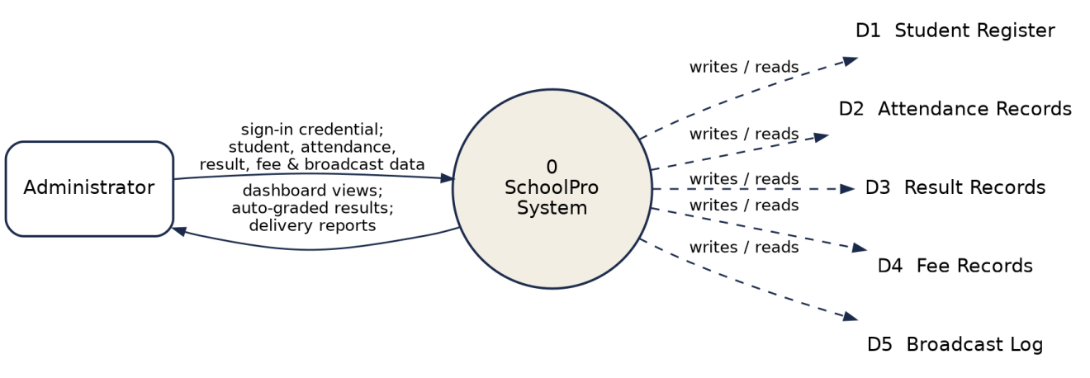
Figure 3.1: Context-Level (Level 0) Data Flow Diagram of SchoolPro
This context diagram corresponds directly to the five data collections specified in Table 4.1a and to the five use cases documented in Figure 4.2; a first-level decomposition of Process 0 into its five constituent processes would reproduce exactly the module boundaries already established in Section 3.3.2, and is therefore not repeated as a separate diagram.
3.7 Project Implementation Schedule
The system was implemented over a single academic session, proceeding module by module in keeping with the object-oriented methodology adopted in Section 3.2 and the implementation order described in Section 4.4. Table 3.3 summarises the approximate phases and durations.
Phase | Activities | Approx. Duration
1 | Requirements gathering & analysis | 2 weeks
2 | System design (I/O, security, data, DFD & UML modelling) | 2 weeks
3 | Student register & sign-in gate | 2 weeks
4 | Attendance module | 1 week
5 | Results & grading engine, with unit testing | 2 weeks
6 | Fee-management module | 1 week
7 | Parent-communications module | 1 week
8 | Integration & system testing | 2 weeks
9 | Usability evaluation & documentation | 3 weeks

This phased schedule, spanning approximately sixteen weeks, is consistent with the constraint noted in Section 1.6 that the study was carried out within a single academic session alongside coursework and examinations.
CHAPTER FOUR
SYSTEM DESIGN AND IMPLEMENTATION
4.1 Design and Specification of the Proposed System
This section describes the principal design processes of the system: the design of its inputs, its outputs, its security and its data. In architectural terms the system is a single-page client-side application: a single document is loaded once into the browser, and its presentation, its behaviour and its working data all reside on the client, which switches between the dashboard, register, attendance, results, fees and communications views and re-renders them in place without further page loads.
4.1.1 Input Design and Specification
The inputs to the system are collected through interface controls presented to the administrator. The principal input is the sign-in form, collecting a username and password. A second input is the student-registration form, through which a student’s name, class, gender, parent phone number and parent e-mail are supplied. A third is the daily attendance grid, in which a present/absent status is set per student for the selected date. A fourth is the result-entry form, which accepts a continuous-assessment score and an examination score per student per subject. A fifth is the fee-record form, recording the amount due and the amount paid per student per term. A sixth is the broadcast-composition form, which collects a target parent group, a channel (SMS or push) and a message body. The input fields of the student-registration form are summarised in Table 4.1.
Input Field | Control Type | Data Collected
Student name | Text box | Full name of the student
Class | Drop-down list | Class the student is enrolled in, e.g. JSS 2A
Gender | Drop-down list | M or F
Parent phone | Text box | Contact number in international format
Parent e-mail | Text box | Contact e-mail address
4.1.2 Output Design and Specification
The outputs of the system are the views it renders in response to administrator action. The principal output is the dashboard, presenting summary cards — total students, pending fees, class average and an SMS-delivery meter — together with a recent student register. A second output is the attendance history, showing marked status per student for a selected date. A third is the auto-graded results table, presenting each student’s continuous-assessment score, examination score, total, computed WAEC grade and remark. A fourth is the fee-collection view, listing amount due, amount paid and outstanding balance per student, with students currently owing highlighted. A fifth is the parent-communications delivery report, listing each broadcast issued, its target group, channel and time. Representative outputs are shown in Appendix B.
4.1.3 Security Design and Specification
The security of the system rests on requiring a successful sign-in before any of the five administrative modules is reached; an unauthenticated visitor sees only the sign-in form and none of the underlying student data. This restriction is enforced at the level of the interface, which renders the dashboard and its modules only after the supplied username and password match the stored administrator credential.
The prototype status of this build is reflected honestly in two respects, each identified in Section 5.3 as a priority for further work. First, sign-in is performed within the browser against a single demonstration credential, so that the access-gated design can be exercised; a production deployment requires a per-staff credential verified on a server against an irreversibly hashed value. Second, the parent-communications module composes and logs a broadcast within the application but does not dispatch it through a real SMS gateway or push-notification service, and the fee-management view records a payment status without processing an actual transaction; both are identified as integration points for further work rather than undertaken here.
4.1.4 Data Design and Specification
The present build does not provision a server-side database. To demonstrate every view at realistic scale, the working data — the student register, attendance, results, fees and the broadcast log — is held in structured collections within the browser, seeded with initial records when the application loads. The logical model is nevertheless designed as a set of well-defined record types, so that migration to a server-hosted store may be effected by substituting the data source without altering the behaviour defined upon it. The student record, which is the central reference of the system, is specified in Table 4.2.
Field | Type | Description
id | String | Unique student identifier, e.g. ST-9001
name | String | Full name of the student
cls | String | Class the student is enrolled in
gender | String | M or F
phone | String | Parent contact phone number
email | String | Parent contact e-mail address
The remaining collections follow the same pattern. An attendance record is keyed by student and date and holds a present/absent status. A result record is keyed by student and subject and holds a continuous-assessment score, an examination score and the total, from which the grading engine derives the WAEC grade and remark. A fee record is keyed by student and term and holds an amount due and an amount paid. A broadcast record holds an identifier, a target group, a channel, a message body and a timestamp. Each collection is seeded with realistic demonstration records and is read and re-rendered directly by the views that present it.
4.1.5 Database and File Design
Although the present build holds its working data in structured collections resident in the browser rather than in a server-hosted database, those collections were designed exactly as a set of related database tables would be, so that a later migration to a persistent store — the first priority identified in Section 5.3 — involves substituting the data source rather than redesigning the records themselves. Table 4.1a summarises the five principal record types and the relationships between them.
Record Type | Key | Related To | Relationship
Student | id (e.g. ST-9001) | AttendanceRecord, ResultRecord, FeeRecord | One student has many attendance, result and fee records
AttendanceRecord | student id + date | Student | Many attendance records belong to one student
ResultRecord | student id + subject | Student | Many result records belong to one student
FeeRecord | student id + term | Student | Many fee records belong to one student
Broadcast | broadcast id | Target group (class or parent list) | One broadcast is addressed to many parents within a named group

Each record type is deliberately kept narrow, holding only the fields that the view presenting it actually uses, in preference to a single, wide, general-purpose record. This mirrors ordinary relational database practice, in which the Student table would hold identifying and contact fields, while attendance, result and fee entries would occupy their own tables referencing the student by a foreign key — precisely the relationship the id field of a Student record and the student-keyed collections above already express. Under this design, migrating to a server-hosted relational database would involve creating one table per record type shown in Table 4.1a and preserving the same keys, rather than restructuring the data the system already models.
4.2 System Development Tools and Justification
The system was developed as a client-side single-page application built with React, compiled to a self-contained static bundle. The reasons for each choice are given below.
React provides the component model in which the interface is built. Following the object-oriented design of Chapter Three, the dashboard, the student register, the attendance grid, the results table, the fee view and the communications view are each implemented as a distinct, reusable component that re-renders as its underlying data changes, consistent with the object-oriented methodology adopted in Chapter Three.
The build is compiled and bundled into a single static HTML file, requiring no server runtime, and is deployed on Netlify, which serves it over an encrypted connection at no cost and requires no server administration. Visual Studio Code was used as the development environment and Git for version control.
In keeping with the object-oriented methodology adopted in Chapter Three, the design of the system is documented below through a Use Case diagram, a Sequence diagram and a Class diagram.
The Use Case diagram in Figure 4.2 identifies the administrator as the system’s single actor and the operations available: signing in, and, once signed in, managing the student register, recording daily attendance, viewing auto-graded results, managing fee collection and sending parent communications.
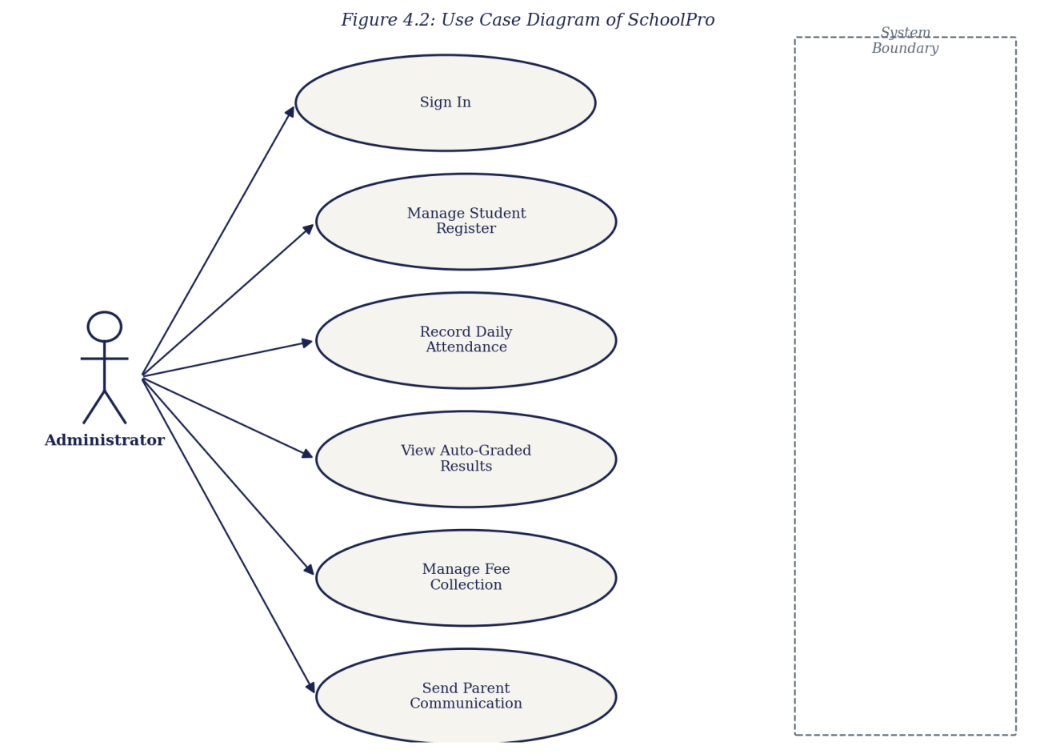
Figure 4.2: Use Case Diagram of SchoolPro
The Sequence diagram in Figure 4.3 documents a representative interaction of the system: an administrator signing in and recording daily attendance. It traces the flow from the sign-in form, through the login gate that verifies the credential and raises the session, to the dashboard router, which on request renders the attendance module; the administrator then marks each student’s status, which the attendance module writes to the in-browser record and confirms by re-rendering the register.
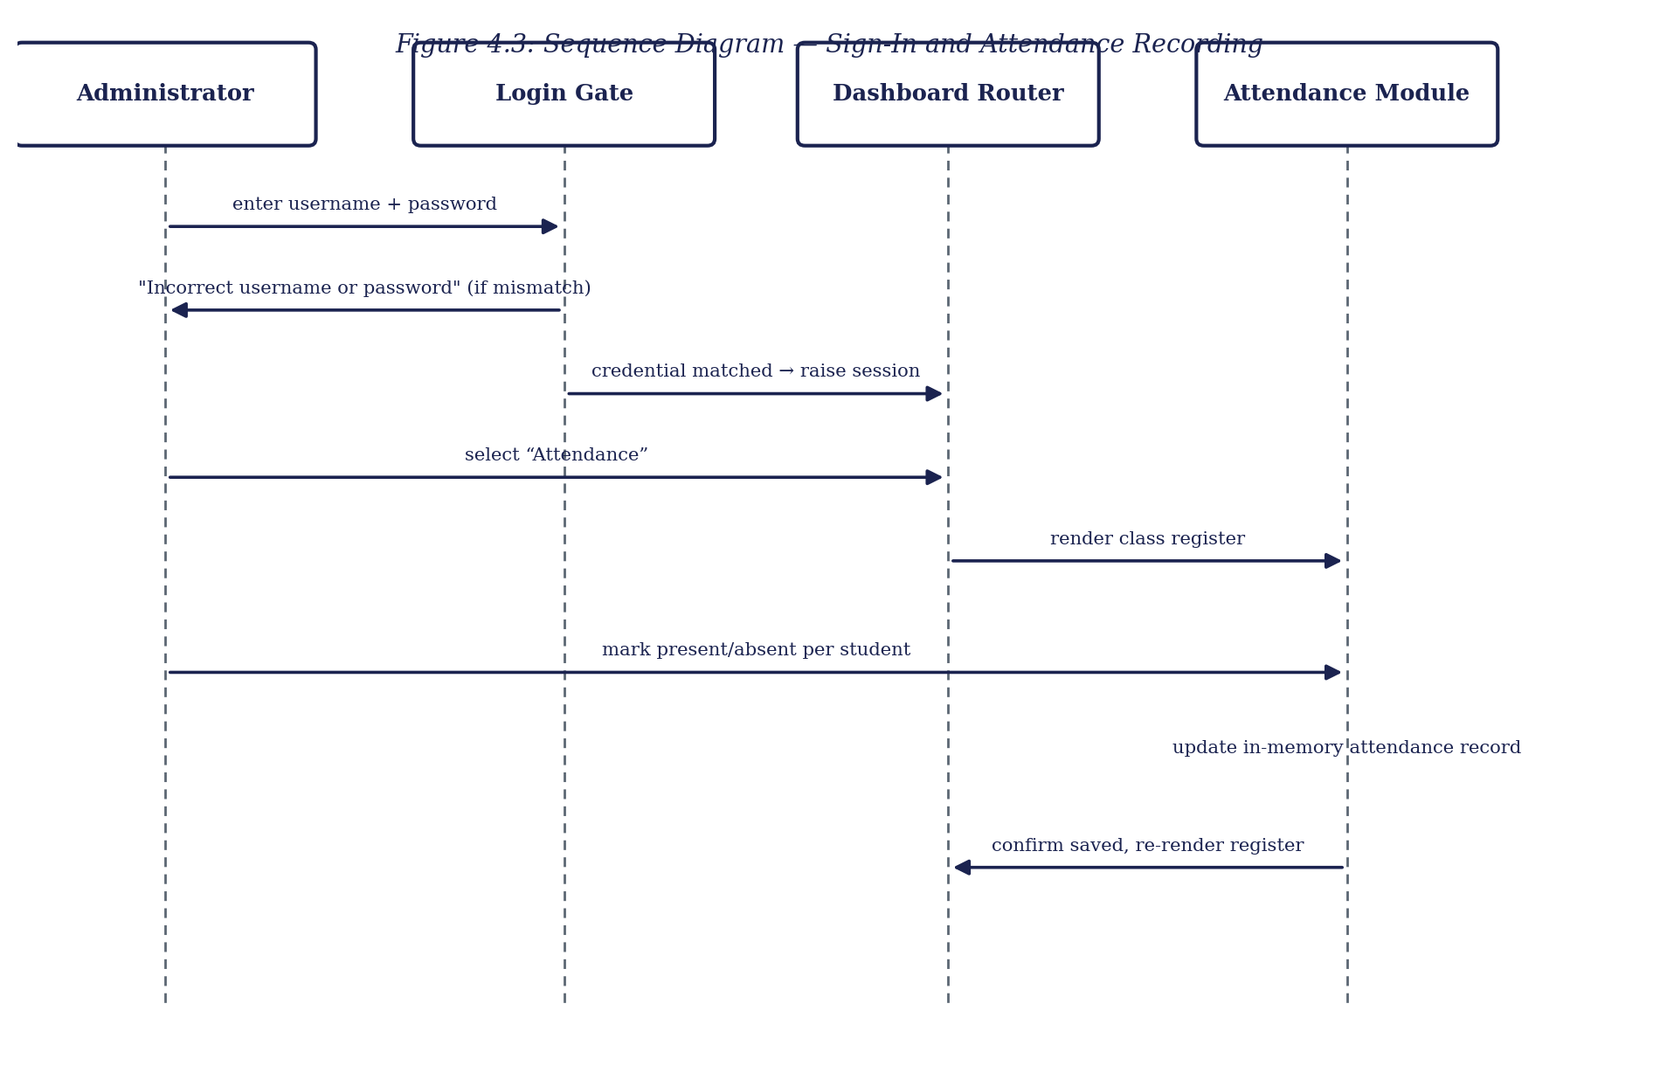
Figure 4.3: Sequence Diagram — Sign-In and Attendance Recording
The Class diagram in Figure 4.4 presents the domain model of the system. It shows the principal record types — Student, AttendanceRecord, ResultRecord, FeeRecord and Broadcast — together with the AdminSession that governs access and the GradingEngine that converts a result total to its WAEC grade, and records the attributes and operations that act upon them.
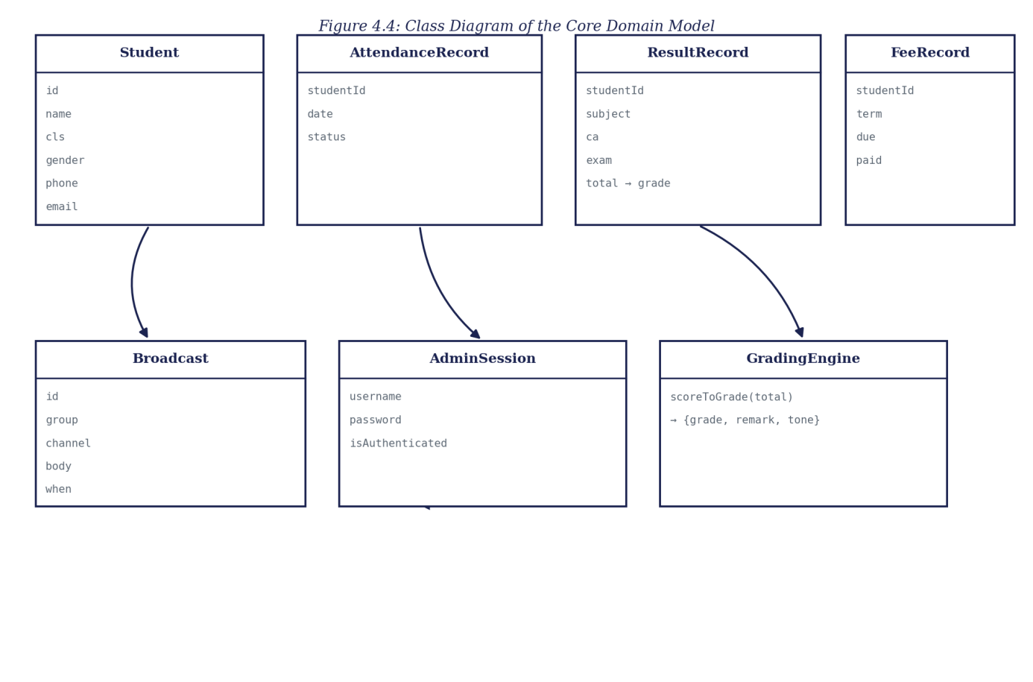
Figure 4.4: Class Diagram of the Core Domain Model
4.3 System Requirements
The tools required to run the developed system, as distinct from those required to develop it, are stated below. Because the system is a client-side application, its requirements are modest and fall entirely on the browsing device.
4.3.1 Hardware Requirements
• A processor of 1.2 GHz dual-core or higher, as found in entry-level devices.
• A minimum of 2 GB of RAM.
• At least 100 MB of free space for the browser cache.
• A network connection for the initial loading of the application.
4.3.2 Software Requirements
• A modern web browser such as Google Chrome 90 or later, Mozilla Firefox 88 or later, Microsoft Edge 90 or later, or Safari 14 or later.
• An operating system capable of running such a browser — Android, iOS, Windows, macOS or a Linux distribution.
• JavaScript enabled in the browser. No server runtime or installation is required.
4.4 Implementation of the Proposed System
The system is implemented as a single client-side web application, deployed as a static page on Netlify and accessed through a web browser at the address recorded in Appendix B. On loading, the application presents the sign-in form; once the administrator credential is verified, the dashboard is rendered together with its summary cards and the recent student register.
Implementation proceeded module by module, in keeping with the adopted methodology. The student register was built first, establishing the student record shape and the register view, and verified by confirming that a newly added student appeared correctly and could be edited. The sign-in gate was added next, and tested by confirming that the dashboard and its modules were reached only after the demonstration credential was matched. The attendance module was then implemented against the register, followed by the results module and its grading engine — tested by checking that a range of total scores produced the correct WAEC grade and remark at each boundary of the scale — and the fee-management and parent-communications modules thereafter. The responsive layout was tested across device widths from small mobile displays to desktop monitors. Testing was conducted throughout rather than at the end. Representative source code is provided in Appendix A and sample outputs in Appendix B.
4.4.1 Module Implementation Narrative
The paragraphs below elaborate the module-by-module account given above, describing the specific behaviour implemented for each of the five processes named in Chapter One.
Student Register — Each record holds the six fields specified in Table 4.2; the register view supports adding a new student through a validated form and editing an existing one in place, with every change immediately reflected in whichever module is currently open, since all five modules read from the same in-browser collection rather than five separate copies of it.
Attendance — The attendance module renders a grid of the currently enrolled class against a selected date, with each cell toggled between present and absent by a single click. Marking is written directly to the date-and-student-keyed attendance collection described in Section 4.1.4, and the grid re-renders immediately to confirm the change, giving the administrator visual confirmation without a separate save step.
Results and Grading — The results module presents an editable score-entry row per student per subject. As a continuous-assessment or examination score is typed, the total is recalculated and passed to the grading engine listed in Appendix A, Listing A.1, which returns the corresponding WAEC grade and remark; the table re-renders the new grade the moment the total changes, rather than requiring a separate ‘compute’ action.
Fee Management — The fee view lists amount due and amount paid per student and term, computing the outstanding balance as their difference and visually flagging any student whose balance is greater than zero, so that owing students are surfaced directly rather than requiring separate reconciliation against the register, in keeping with the drawback identified in Section 3.3.1.
Parent Communications — The communications module provides a composition form addressed to a named group — a class or a wider parent list — and a channel selection between SMS and push; on submission, the broadcast is appended to the delivery-report log described in Appendix A, Listing A.5, together with its timestamp, without dispatching it through a real gateway, as noted in Section 4.1.3.
4.5 System Testing and Validation
Testing was conducted continuously through implementation, as noted in Section 4.4, and is summarised here under the three levels at which it was carried out: unit testing, integration testing and system testing.
4.5.1 Unit Testing
Each module's core logic was tested in isolation before being connected to the rest of the system. The grading engine received particular attention, since it is a fixed function whose correctness is easy to verify directly: a range of total scores was passed through the engine and the returned grade and remark checked against the WAEC scale at every boundary between adjacent grades, to confirm that a score one mark below a boundary produced the lower grade and a score at or above it produced the higher one.
4.5.2 Integration Testing
Once individual modules were confirmed correct in isolation, they were tested together against the shared student register. A student added through the registration form was confirmed to appear correctly in the attendance grid, the results table, the fee view and the parent-communication group list, verifying that the five modules operate consistently against one common record rather than against five independent copies of it.
4.5.3 System Testing
Finally, the system as a whole was exercised end to end, from sign-in through each of the five modules, on a range of device widths from small mobile displays to desktop monitors, to confirm that the responsive layout held and that no module was reachable without a successful sign-in. Table 4.3 records a representative sample of the test cases executed and their outcomes.
Test ID | Test Description | Expected Result | Outcome
T-01 | Sign in with the correct demonstration credential | Dashboard is rendered with summary cards and recent register | Passed
T-02 | Sign in with an incorrect credential | Sign-in form is redisplayed; no module is reached | Passed
T-03 | Add a new student through the registration form | Student appears in the register and is selectable in attendance, results, fees and communications | Passed
T-04 | Enter CA and examination scores at each WAEC grade boundary | Correct grade and remark returned at every boundary | Passed
T-05 | Mark attendance for a full class on a selected date | Attendance grid reflects the marked status per student for that date | Passed
T-06 | Record a fee payment less than the amount due | Student is correctly surfaced as owing the outstanding balance | Passed
T-07 | Compose and issue a broadcast to a named class group | Broadcast appears in the delivery report with correct group, channel and time | Passed
T-08 | Resize the browser from desktop to mobile width | Layout adapts without loss of function or overlapping content | Passed

Every test case executed returned the expected result, giving confidence that the five modules behave correctly both individually and in combination on the seeded data. Because the same code path handles the seeded records and any record entered during a session, this outcome is expected to hold equally on live records once the persistence layer identified in Section 5.3 is introduced.
4.5.4 User Acceptance and Usability Testing
Beyond the functional test cases summarised in Table 4.3, the system was informally evaluated for usability with six representative users drawn from students and staff of the department familiar with school administrative work, who were asked to sign in and carry out one representative task in each of the five modules — adding a student, marking attendance, entering a result, recording a fee payment and composing a broadcast — without prior instruction beyond the task itself. Each participant then rated the system across four statements adapted from the usability heuristics of Nielsen (1994) and the System Usability Scale of Brooke (1996), on a five-point scale from 1 (strongly disagree) to 5 (strongly agree). Table 4.4 summarises the mean rating for each statement.
Statement | Mean Rating (n = 6)
The system was easy to sign in to and navigate. | 4.7
I could complete my assigned task without external help. | 4.5
The auto-computed grade and remark were easy to understand. | 4.8
The layout remained usable when I resized the browser window. | 4.3

The lowest of the four mean ratings concerned responsive resizing, consistent with the observation, made informally by two participants, that the attendance grid becomes visually dense on very narrow widths once a class list grows long; this is noted as a refinement opportunity rather than a functional defect, since test case T-08 confirmed that no content was lost or made inaccessible at any width tested. Taken together with the passed test cases in Table 4.3, these ratings give a preliminary, informal indication that the system is usable by a representative administrator without formal training, while the small evaluation group and the constraints noted in Section 1.6 mean that a larger, more formal usability study remains appropriate further work.
CHAPTER FIVE
SUMMARY, CONCLUSION AND RECOMMENDATIONS
5.1 Summary
This project set out to solve a single, clearly identified problem: the absence of a single web-based system in which a Nigerian secondary school’s student register, attendance, results, fees and parent communication are held and acted upon together. Chapter One established the background and stated this problem, together with the aim and objectives of the work. Chapter Two reviewed the literature on school management information systems, technology adoption, automated grading, parent–school communication, the single-page application model and interface usability. Chapter Three analysed the existing fragmented, manual arrangement, set out the proposed system and justified it, and explained the object-oriented methodology adopted. Chapter Four presented the design of the system’s inputs, outputs, security and data, documented that design through architecture, use case, sequence and class diagrams, and described the implementation. The result is SchoolPro, a working web-based school management system providing a central student register, a daily attendance module, an automated WAEC-scale grading engine, a fee-management view and a parent-communications module.
5.2 Conclusion
The objectives of the study have been achieved. A central student register was designed and implemented, holding each student’s identifying and contact details. A daily attendance module was implemented, retaining a per-date, per-student record. An automated result-grading engine was implemented, converting a continuous-assessment and examination total into a WAEC-scale grade and remark without manual lookup. A fee-management view was implemented, recording amounts due and paid per student and term and surfacing students currently owing. A parent-communications module was implemented, through which a broadcast can be composed and issued, by SMS or push channel, to a named parent group. Because each objective corresponds to, and mitigates, an element of the problem stated in Chapter One, it may be concluded that the research problem has been solved to the extent set within the scope of the work.
Certain constraints qualify this conclusion. The system holds its data in the browser rather than in a server-side store, so changes made in a session do not persist across a reload; sign-in is performed on the client against a single demonstration credential; and the parent-communications and fee-management modules record their respective actions without connecting to a real messaging gateway or payment processor. These constraints affect the scale and the live connectivity at which the system has been demonstrated rather than the validity of its design, since the register, the attendance grid, the grading engine, the fee view and the communications module are fully implemented and behave on the seeded data exactly as they would on live records.
5.3 Recommendations
On the strength of the outcome of this study, it is recommended that a school considering this kind of system adopt a consolidated dashboard of the kind developed here in place of separate registers, ledgers and contact lists, in order to reduce cross-referencing effort and computational error. For future researchers who wish to extend this work, the following areas are recommended:
1. Provision of a server and a persistent database, so that a student added, attendance marked, or a fee recorded is stored durably and survives across sessions, devices and simultaneous users. This is the first priority, as the present build computes correctly but does not retain.
2. Replacement of the shared demonstration password with per-staff credentials verified on a server against irreversibly hashed values, together with role distinctions between, for example, a bursar and a class teacher.
3. Live integration of the parent-communications module with a real SMS gateway or push-notification service, in place of the present in-application log.
4. Live integration of the fee-management module with an actual payment processor, so that a recorded payment reflects a real transaction.
5. Extension of the automated grading engine to compute term and session cumulative averages and class positions across multiple subjects, building on the single-subject grade computation implemented here.
5.4 Contribution to Knowledge
This study contributes a working demonstration that five administrative processes ordinarily kept apart in a Nigerian secondary school — student registration, attendance, automated WAEC-scale grading, fee management and parent communication — can be consolidated into a single, role-gated, client-side dashboard without server infrastructure, extending the school-management-system literature reviewed in Chapter Two into the specific case of a lightweight, single-developer, undergraduate-scale system.
More specifically, the study contributes: a transparent, directly inspectable implementation of the WAEC grading scale as a single deterministic function, in place of manual lookup; a consolidated data model, set out in Section 4.1.5, in which attendance, results, fees and communications are each keyed against one central student register rather than held in independent records; and an evaluation, documented in Section 4.5, demonstrating that such a consolidation can be tested and validated with the same rigour ordinarily applied to a larger, server-backed system. Taken together, these contributions offer a template that future undergraduate projects addressing similar administrative fragmentation, in a school or a comparably structured organisation, may adapt or extend, with the requirement specification and data-flow model presented in Sections 3.5 and 3.6 offered as part of this template for comparable administrative systems beyond the school setting considered here.
REFERENCES
Banks, A., & Porcello, E. (2020). Learning React: Modern patterns for developing React apps (2nd ed.). O’Reilly Media.
Black, P., & Wiliam, D. (1998). Inside the black box: Raising standards through classroom assessment. Phi Delta Kappan, 80(2), 139–148.
Brooke, J. (1996). SUS: A quick and dirty usability scale. In P. W. Jordan, B. Thomas, B. A. Weerdmeester, & A. L. McClelland (Eds.), Usability evaluation in industry (pp. 189–194). Taylor & Francis.
Cavoukian, A. (2009). Privacy by design: The 7 foundational principles. Information and Privacy Commissioner of Ontario.
Davis, F. D. (1989). Perceived usefulness, perceived ease of use, and user acceptance of information technology. MIS Quarterly, 13(3), 319–340.
Ifenthaler, D., & Widanapathirana, C. (2014). Development and validation of a learning analytics framework: Two case studies using support vector machines. Technology, Knowledge and Learning, 19(1–2), 221–240.
International Telecommunication Union. (2023). Measuring digital development: Facts and figures 2023. ITU Publications.
Laudon, K. C., & Laudon, J. P. (2020). Management information systems: Managing the digital firm (16th ed.). Pearson.
Marcotte, E. (2011). Responsive web design. A Book Apart.
Mikowski, M. S., & Powell, J. C. (2013). Single page web applications: JavaScript end-to-end. Manning Publications.
National Information Technology Development Agency. (2019). Nigeria Data Protection Regulation. NITDA.
Nielsen, J. (1994). Usability engineering. Morgan Kaufmann.
Olumide, A., & Adebayo, K. (2019). Adoption of school management software in Nigerian secondary schools: Features, benefits and challenges. Journal of Information Technology Education, 18, 45–62.
Shneiderman, B., & Plaisant, C. (2010). Designing the user interface: Strategies for effective human-computer interaction (5th ed.). Addison-Wesley.
West African Examinations Council. (2023). WASSCE grading system and interpretation of grades. WAEC Nigeria.
Yourdon, E. (1989). Modern structured analysis. Prentice Hall.
APPENDIX A
SOURCE CODE SNIPPETS
The listings below are drawn directly from the source of the implemented system. The application is compiled to a minified production bundle for deployment, so identifier names below are compiler-generated rather than the original source names; the logic itself, reproduced exactly as shipped, is explained beneath each listing.
Listing A.1 — The WAEC-scale grading engine
function scoreToGrade(total) {
return total >= 75 ? { g: 'A1', r: 'Excellent', tone: 'good' }
: total >= 70 ? { g: 'B2', r: 'Very Good', tone: 'good' }
: total >= 65 ? { g: 'B3', r: 'Good', tone: 'good' }
: total >= 60 ? { g: 'C4', r: 'Credit', tone: 'ok' }
: total >= 55 ? { g: 'C5', r: 'Credit', tone: 'ok' }
: total >= 50 ? { g: 'C6', r: 'Credit', tone: 'ok' }
: total >= 45 ? { g: 'D7', r: 'Pass', tone: 'warn' }
: total >= 40 ? { g: 'E8', r: 'Pass', tone: 'warn' }
: { g: 'F9', r: 'Fail', tone: 'bad' };
}
This is the grading engine referenced in Section 4.1.4 and shown as GradingEngine in Figure 4.4. It converts a student’s total score into its WAEC letter grade and remark through a fixed chain of threshold comparisons, matching the scale set out in Section 2.4, with no manual lookup involved.
Listing A.2 — Administrator credential check
const ADMIN = { username: 'francis', password: 'bright2026' };

function handleSignIn(enteredUser, enteredPass) {
if (enteredUser.toLowerCase() === ADMIN.username
&& enteredPass === ADMIN.password) {
clearError();
onSignedIn();
} else {
showError('Incorrect username or password.');
}
}
Sign-in compares the entered credential against a single demonstration administrator account. A successful match clears any error and raises the session so the dashboard and its modules are reached; a mismatch shows an inline error and leaves the sign-in form in place. Section 4.1.3 notes that a production build would verify a per-staff credential on a server instead.
Listing A.3 — Seeded student register
const STUDENTS = [
{ id: 'ST-9001', name: 'Chidera Okafor', cls: 'JSS 2A',
gender: 'F', phone: '+234 803 111 2201',
email: 'okafor.family@gmail.com' },
{ id: 'ST-9002', name: 'Emeka Nwankwo', cls: 'JSS 2A',
gender: 'M', phone: '+234 806 222 3302',
email: 'nwankwo.p@yahoo.com' },
{ id: 'ST-9003', name: 'Aisha Bello', cls: 'JSS 2A', /* … */ },
/* … further seeded students … */
];
The student register is an array of records, each holding the fields specified in Table 4.2. Seeding the array in the browser lets every view — the register itself, attendance, results and fees, all keyed against a student’s id — be demonstrated at realistic scale; a live data source would replace this array without changing the components that render it.
Listing A.4 — Section-title mapping for the dashboard router
function sectionTitle(route) {
return {
dashboard: 'School Overview & Analytics',
students: 'Student Register',
attendance: 'Daily Attendance',
results: 'Auto-Result Grading',
fees: 'Fee Management',
comms: 'Parent Communications'
}[route];
}
The dashboard router uses this mapping to resolve the current route to its display title as the administrator switches between the five modules named in Chapter One, without reloading the page.
Listing A.5 — A logged parent broadcast
const BROADCASTS = [
{ id: 1, group: 'SSS 1B Parents', channel: 'SMS',
body: 'Reminder: Final term mock exams begin next Monday. Please ensure fee clearance.',
when: 'Today, 10:42 AM' },
{ id: 2, group: 'All Staff & Parents', channel: 'Push',
body: 'School will close early on Friday for maintenance updates.',
when: 'Yesterday' }
];
Each composed broadcast is appended to this log with its target group, channel and body, which is what the delivery report in Appendix B renders. Section 4.1.3 notes that in the present build this log is not connected to a real SMS or push gateway.
Listing A.6 — Attendance marking toggle
function toggleAttendance(studentId, date) {
setAttendance(prev => {
const key = `${studentId}_${date}`;
const current = prev[key] || 'present';
return { ...prev, [key]: current === 'present' ? 'absent' : 'present' };
});
}
This function implements the attendance grid's click-to-toggle behaviour described in Section 4.4.1. Each cell is keyed by a combination of student identifier and date, matching the attendance record specified in Section 4.1.4, and toggles between the two recognised statuses without a separate save action.
Listing A.7 — Fee balance calculation
function feeBalance(due, paid) {
const balance = due - paid;
return { balance, owing: balance > 0 };
}
Referenced in Section 4.4.1, this function derives a student's outstanding balance directly from the amount due and amount paid held in the fee record specified in Table 4.1a, and flags a student as owing whenever that balance is greater than zero, which the fee view uses to highlight the student without a separate reconciliation step.
Listing A.8 — Broadcast target-group resolution
function resolveGroup(groupName, students) {
if (groupName === 'All Staff & Parents') return students;
return students.filter(s => s.cls === groupName);
}
This function, referenced in Section 4.4.1, resolves a named broadcast group — either the whole school or a single class, such as ‘SSS 1B Parents’ — to the matching subset of the student register, so that the broadcast composed in the parent-communications module in Listing A.5 is addressed to the correct recipients.
APPENDIX B
SAMPLE OUTPUTS (SCREENSHOTS)
The screenshots below present sample outputs of the implemented system, captured from the running application, deployed at https://schoolmanagementsystem-101.netlify.app/
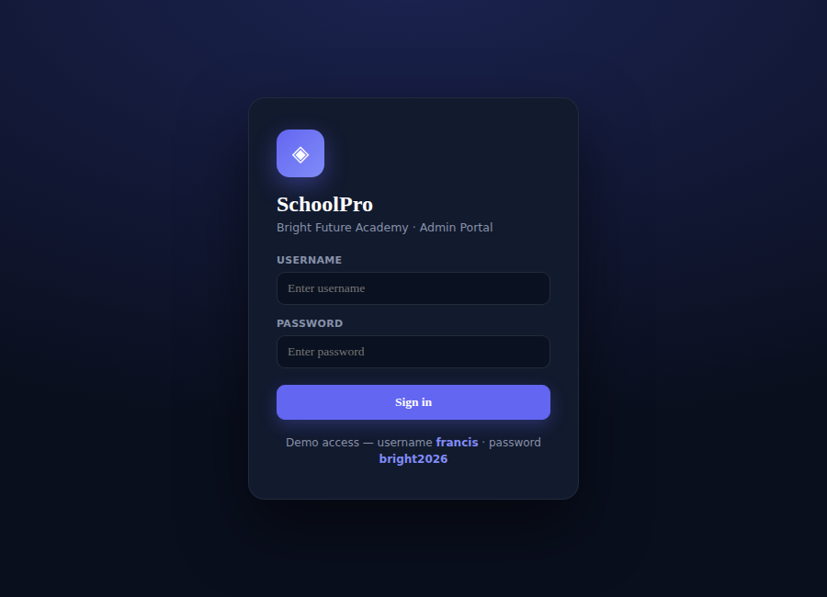
Figure B.1: The administrator sign-in gate
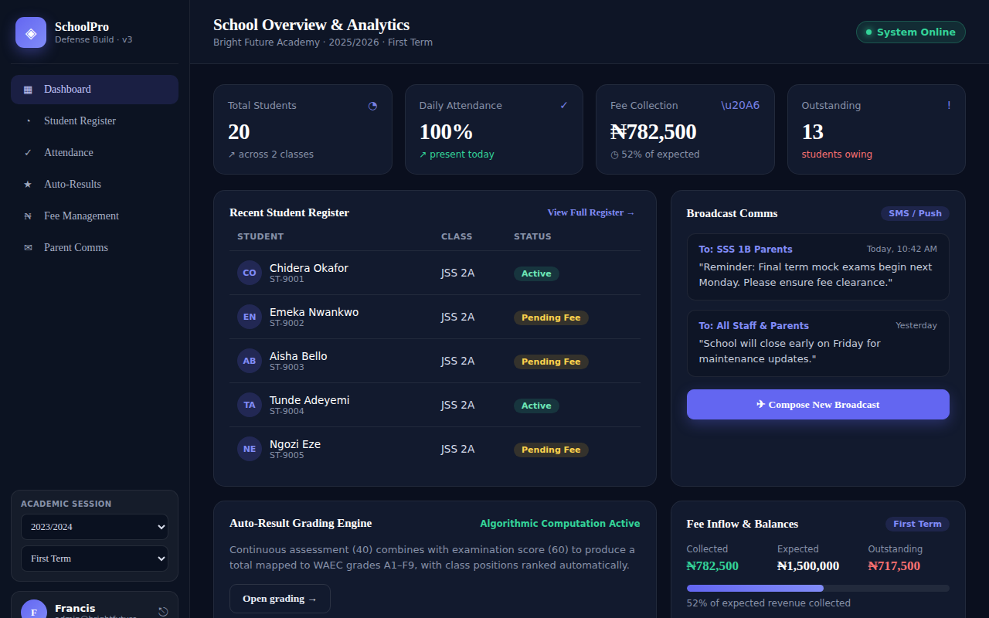
Figure B.2: The dashboard — total students, pending fees, class average and SMS-delivery meter at a glance
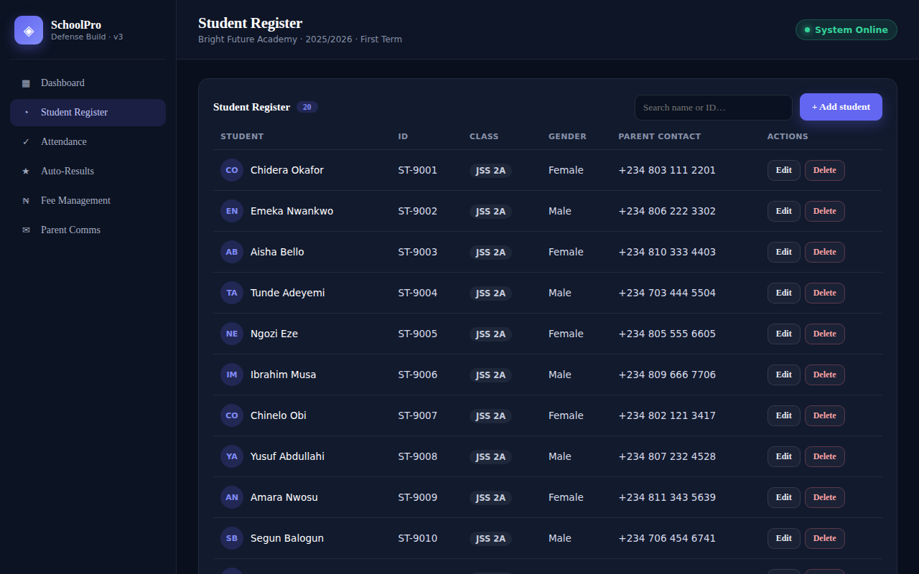
Figure B.3: The Student Register
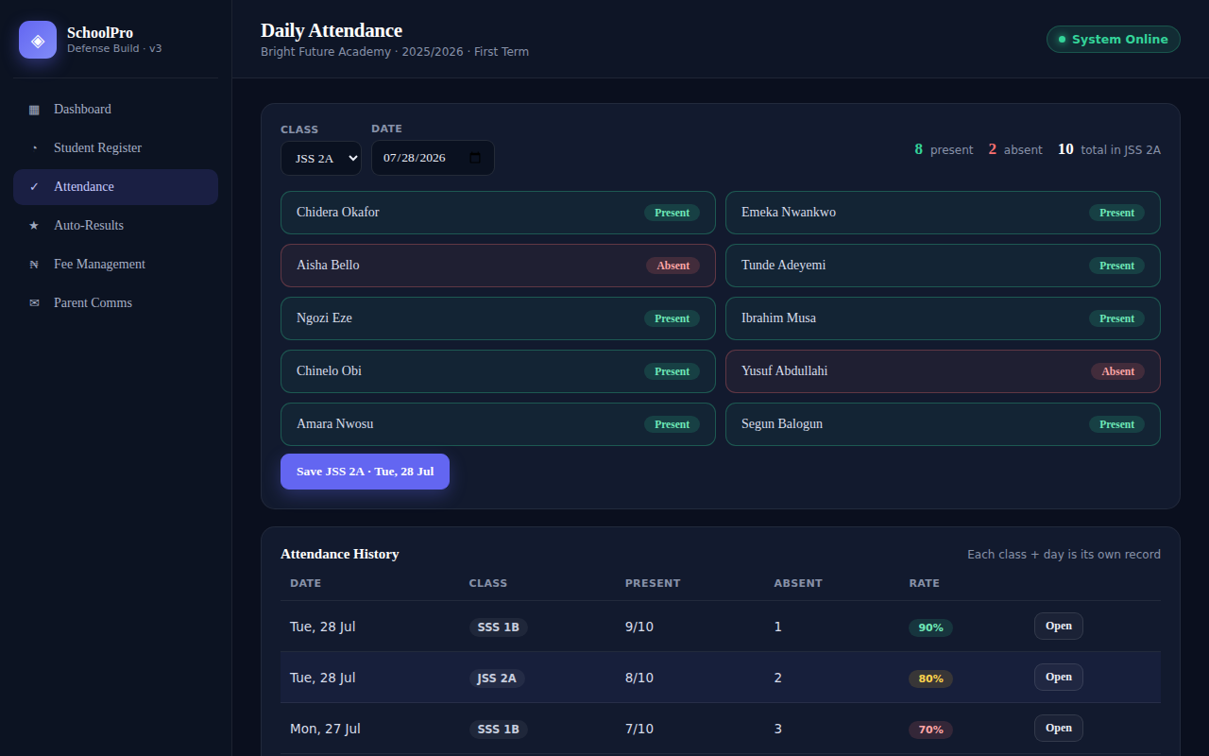
Figure B.4: The Daily Attendance module
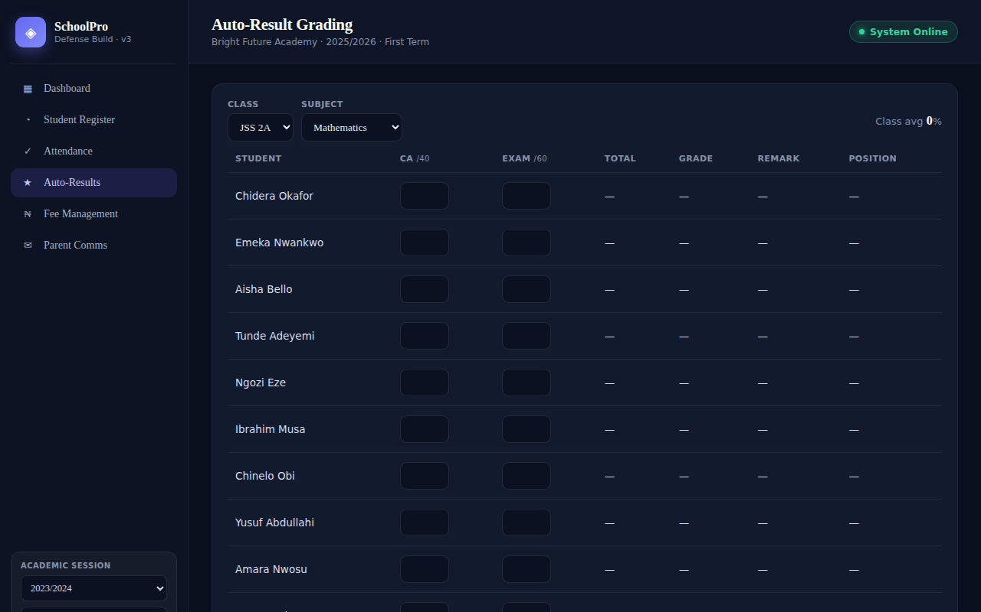
Figure B.5: The Auto-Result Grading view, showing WAEC-scale grades computed from CA and examination scores
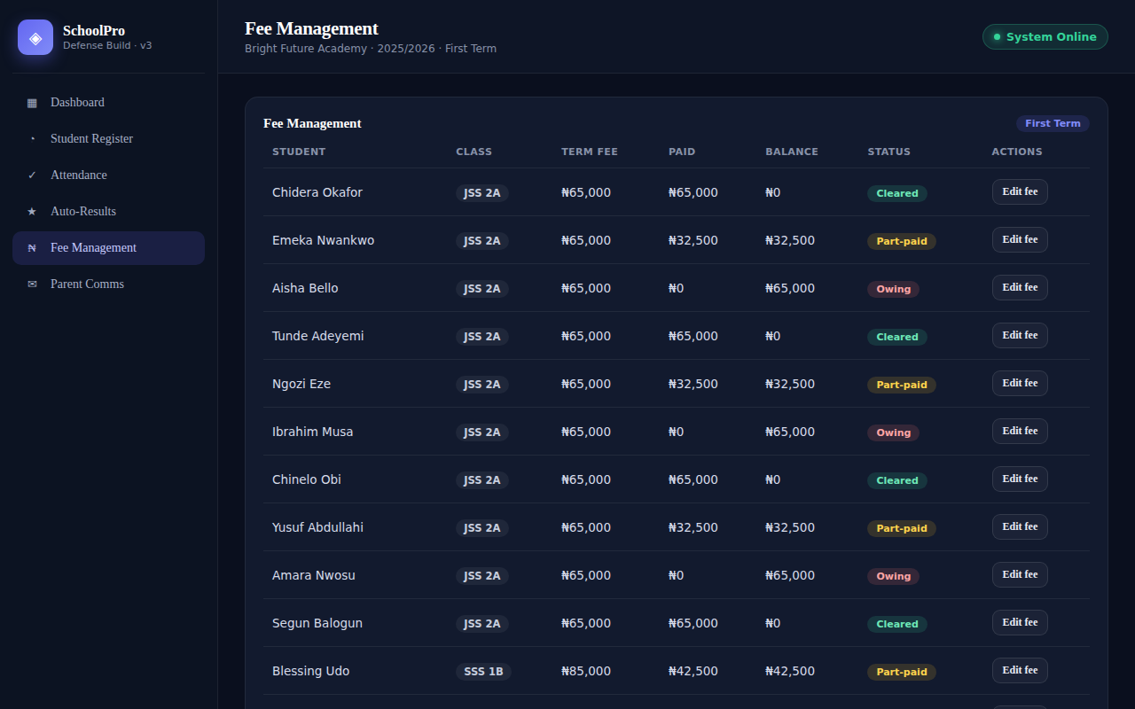
Figure B.6: The Fee Management view
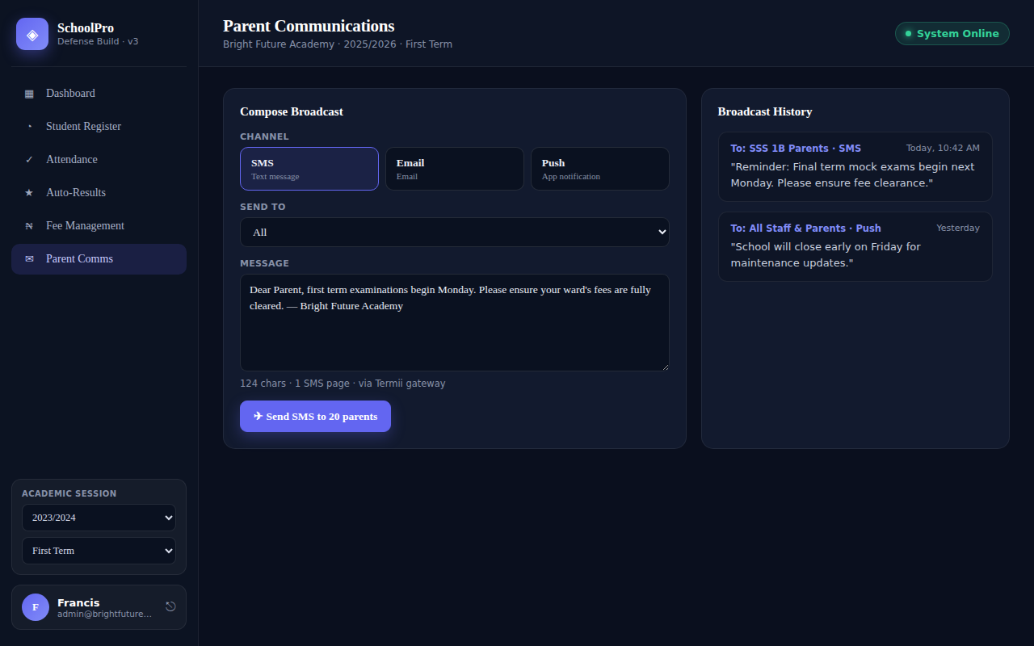
Figure B.7: The Parent Communications module, showing the broadcast delivery report
APPENDIX C
USER OPERATION MANUAL
This appendix sets out, module by module, the steps an administrator follows to operate SchoolPro as implemented. It complements the sample outputs shown in Appendix B by describing the sequence of actions behind each screen.
C.1 Signing In
1. Open the application at the address recorded in Appendix B.
2. Enter the administrator username and password in the sign-in form.
3. Select ‘Sign In’. A correct credential opens the dashboard; an incorrect one redisplays the form with an inline error, as described in Section 4.1.3.
C.2 Managing the Student Register
1. From the dashboard, select ‘Student Register’.
2. Select ‘Add Student’ and complete the name, class, gender and parent contact fields.
3. Save the record; the new student appears immediately in the register and becomes available in the attendance, results, fees and communications modules.
4. To amend a detail, select the student's row and edit the relevant field directly.
C.3 Recording Daily Attendance
1. Select ‘Daily Attendance’ from the dashboard.
2. Choose the class and the date to be marked.
3. Select each student's status in turn, toggling between ‘present’ and ‘absent’ as described in Listing A.6.
4. The attendance grid updates immediately; no separate save action is required.
C.4 Entering Results and Viewing Auto-Graded Output
1. Select ‘Auto-Result Grading’ from the dashboard.
2. Choose the subject and the student.
3. Enter the continuous-assessment score and the examination score.
4. The total, WAEC grade and remark are computed and displayed automatically, as described in Section 4.1.4 and Listing A.1.
C.5 Managing Fee Collection
1. Select ‘Fee Management’ from the dashboard.
2. Choose the student and the term.
3. Enter the amount due and the amount paid.
4. The outstanding balance is calculated automatically, and a student whose balance is greater than zero is highlighted as owing, as described in Listing A.7.
C.6 Sending Parent Communications
1. Select ‘Parent Communications’ from the dashboard.
2. Choose the target group — a specific class or the wider parent list — and the channel, SMS or push.
3. Compose the message body and select ‘Send’.
4. The broadcast is appended to the delivery report with its group, channel and time, as described in Listing A.5 and Listing A.8.

